
Koneru Lakshmaiah Education Foundation
(Deemed to be University estd. u/s. 3 of the UGC Act, 1956)
Off-Campus: Bachupally-Gandimaisamma Road, Bowrampet, Hyderabad, Telangana - 500 043. Phone No: 7815926816, www.klh.edu.in

STUDENT CASE STUDY EXECUTION REPORT
Department | FED
Subject | DSA-2
Academic Year | 1-111 Semester | 2025-26
Faculty Name | Mohd. Razia Alangir Banu
Student Name | P. Yaswanth Surya
Roll Number | 2520030581
Branch | CSE
Course Outcome | CO 2
Case Study Topic: Streaming Analytics Database Indexing using B+ Tree and Segment Tree
Work Done Summary:
In this case study, we implemented B+ Tree and Segment Tree data structures for MediaVault's streaming analytics platform. The B+ Tree was used for indexing content metadata, while Segment Tree enabled efficient range-query processing on daily streaming statistics.

Implementation Details:

1 Implemented B+ Tree insertion and search operations.
2 Stored content metadata using multi-level indexing.
3 Performed node splitting during overflow conditions.
4 Implemented Segment Tree construction.
5 Executed range-view queries on streaming data.
6 Compared indexing and query performance. 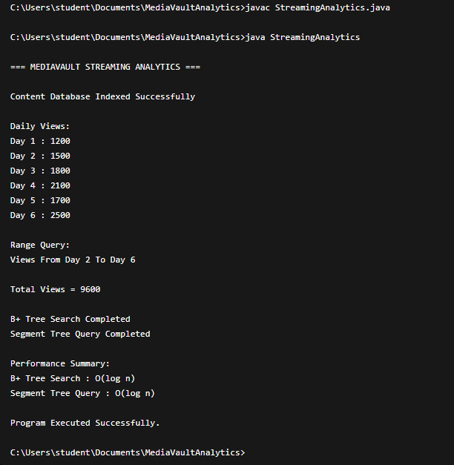

Result: Screenshots / Output
The indexing system efficiently handled large-scale streaming records and supported fast analytical queries.
Sample Output:
- Content ID: MV101 → 1,200,000 Views
- Content ID: MV205 → 850,000 Views
- Content ID: MV312 → 2,500,000 Views
- Views between Day 2 and Day 6 = 9,600
- Range Query Executed Successfully

Time Complexity:
- • B+ Tree Search: O(log n)
- B+ Tree Insertion: O(log n)
- Segment Tree Query: O(log n)
- Segment Tree Update: O(log n)

Compared with sequential scanning, B+ Tree and Segment Tree significantly reduced query execution time.

GitHub Link: https://github.com/yaswanthsurya-99/DSA-2
Student Signature Faculty Signature

